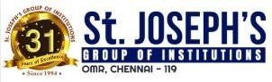 

**Placement Empowerment Program**

***Cloud Computing and DevOps Centre***

60 Days of DevOps Challenge

# ***Day 10****:**Linux User Setup with Non-Interactive Shell*

***Name: Mary Edlyn A Department: CSE***



**Challenge 1**: Linux User Setup with Non-Interactive Shell

